M4 - DEVELOP PRESENTATIONS AND SLIDESHOWS

In this part of the course, you’ll discover how to give an effective presentation about your data analysis. This final module teaches you to construct insightful presentations that resonate with your audience. You'll learn to anticipate and address potential questions and to articulate the limitations of your data, ensuring a robust and credible narrative for your stakeholders.

## Learning Objectives

* Describe best practices for addressing the question-and-answer section of a presentation
* Consider the caveats and limitations associated with the data in a presentation
* Differentiate between strong and weak presentation content
* Describe how junior data analysts are expected to use their presentation skills
* Explain principles and practices associated with effective presentations
* Identify appropriate responses to presentation objections

THE ART AND SCIENCE OF PRESENTATIONS

[Pull it all together](https://www.coursera.org/learn/visualize-data/lecture/39woq/pull-it-all-together)

Welcome back. Now that we're in the share phase of the data analysis process, it's time to show other people what we found.

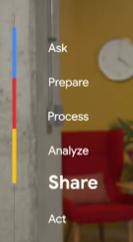

You've already learned about creating data visualizations and how to use data-driven storytelling. Now it's time to talk about actually presenting the data.

Maybe the idea of presenting your findings of stakeholders makes you nervous, or maybe you're getting excited just thinking about it.

Either way, these upcoming videos will get you ready to present like a pro.

Coming up, we'll learn about the art and science of presentations, some best practices you can use for future presentations, and how to bring multiple data sources together to tell the whole story.

As a data analyst, it's important to find answers and make new discoveries during your data analysis, but it's just it's important to share those findings with other people.

So if you're ready, let's get started.

[Present with a framework](https://www.coursera.org/learn/visualize-data/lecture/pCIlZ/present-with-a-framework)

Earlier in this program, you learned how to keep your audience in mind when communicating your data findings. By making sure that you're thinking about who your audience is and what they need to know, you'll be able to tell your story more effectively.

In this video, we'll learn how to use a **strategic framework to help your audience understand the most important takeaways from your presentation**.

**To make your data findings accessible to your audience, you'll need a framework to guide your presentation.** This helps to create logical connections that tie back to the business tasks and metrics.

As a quick reminder, the business task is the question or problem. your data analysis answers.

The framework you choose gives your audience context to better understand your data.

On top of that, it helps keep you focused on the most important information during your presentation.

The framework for your presentation starts with your understanding of the business task.

Raw data doesn't mean much to most people, but if you present your data in the context of the business task, your audience will have a much easier time connecting with it.

This makes your presentation more informative and helps you empower your audience with knowledge. That's why **understanding the business task early on is key**.

Here's an example.

Let's say we're working with a grocery store chain. They've asked us to identify trends and online searches for avocados to help them make seasonal stocking decisions.

During our presentation, we want to make sure that we continue focusing on this task and framing our information with it. Let's check out this example slide presentation. We can begin our presentation by framing it with the business task here.



In this second slide, I've added goals for the discussion.

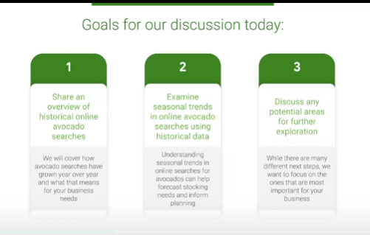

It starts with "share an overview of historical online avocado searches."

Under that, a more detailed explanation: "We'll cover how avocado searches have grown year over year and what that means for your business." Then we'll "examine seasonal trends in online avocado searches using historical data." This is important because "understanding seasonal trends can help forecast stocking needs and inform planning." And finally, "discuss any potential areas for further exploration."

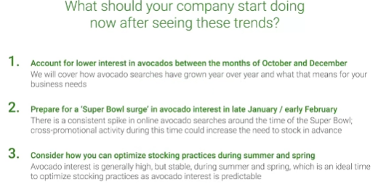

This is where we'll address next steps in the presentation. This clearly outlines the presentation so our audience knows what to expect.

It also lets them know how the information we share is going to be connected to the business task.

You might remember, we talked about telling a story with data before. You can think of this like outlining the narrative. We can do the same thing with our data viz examples. If we're showing this visual graph of annual searches for avocados, we might want to frame it by saying this graph shows the months with the most online searches for avocados last year, so we can expect that this interest in avocados will fall in the same months this year.

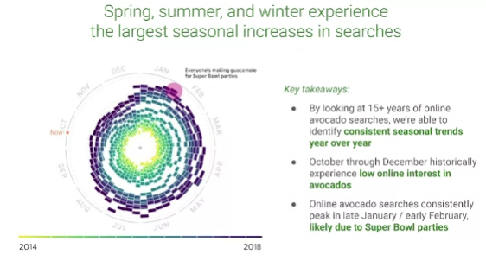

That can even be used in our speaker notes for the slide. This is a great place to add important points you want to remember during the presentation ahead of time. These notes aren't visible to your audience in presentation mode, so they're great reminders you can refer to as you present.

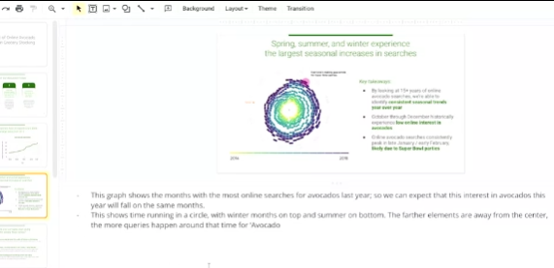

Plus, you could even share your presentation with speaker notes ahead of time to make the content more accessible for your audience.

Using this data, the grocery store can anticipate demand and make a plan to stock enough avocados to match their customers' interests. That's just one way we can use the business task to frame our data and make it easier to understand.

**You also want to make sure you're outlining and connecting with your business metrics** by showcasing what business metrics you use. You can help your audience understand the impact your findings will have.

Think about the metrics we use for our avocado presentation. We track the number of online searches for avocados from different months over several years to anticipate trends and demand.

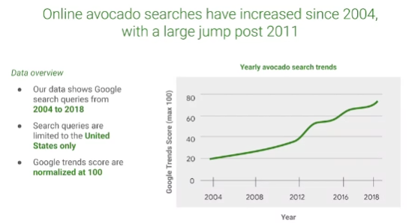

By explaining this in our presentation, it's easy for our audience to understand how we used our data. These data points alone—the dates or number of searches— aren't useful for our audience, but when we explain how they're combined as metrics, the data we're sharing makes so much more sense.

Here's another potential data viz that we want to use.

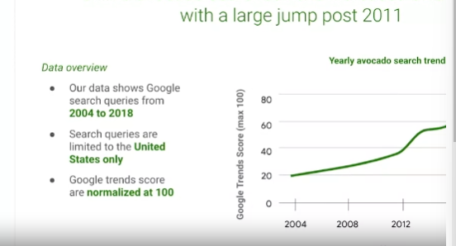

We can frame it for our audience by including some of our metrics. There's an explanation of what time period this data covers: "Our data shows Google search queries from 2004 to 2018." Where we gathered this data from: "Search queries are limited to the United States only." And a quick explanation of how the trends are being measured:

"Google trends scores are normalized at 100." So now that our audience understands the metrics we use to organize this data, they'll be able to understand the graph more clearly. Using a strategic framework to guide your presentation can help your audience understand your findings, which is what the sharing phase of the data analysis process is all about. Coming up, we'll learn even more about how to weave data into your presentations.

[Weave data into your presentation](https://www.coursera.org/learn/visualize-data/lecture/P0cIP/weave-data-into-your-presentation)

Hey, great to have you back. So we know how to use our business tasks and metrics to frame our data findings during a presentation.

Now let's talk about how you work data into your presentations to help your audience better understand and interpret your findings.

First, it's helpful for your audience to understand what data was available during data collection. You can also tell them if any new relevant data has come up, or if you discovered that you need different data.

For our analysis, we used data about online searches for avocados over several years. The data we collected includes all searches with the word "avocado," so it includes a lot of different kinds of searches. This helps our audience understand what data they're actually looking at and what questions they can expect it to answer. With the data we collected on searches containing the word avocado, we can answer questions about the general interest in avocados. But if we wanted to know more about something specific, like guacamole, we'd probably need to collect different data to better understand that part of our search data. Next, you'll want to establish the initial hypothesis. Your initial hypothesis is a theory you're trying to prove or disprove with data. In this example, our business task was to compile average monthly prices. Our hypothesis is that this will show clear trends that can help the grocery store chain plan for avocado demand in the coming year. You want to establish your hypothesis early in the presentation. That way, when you present your data, your audience has the right context to put it in. Next, you'll want to explain the solution to your business tasks using examples and visualizations. A good example is the graph we used last time that clearly visualized the search trend score for the word avocado from year to year. Raw data could take time to sink in, but a good example or visualization can make it much easier for your audience to understand you during a presentation.

Keep in mind, **presenting your visualizations effectively is just as important as the content, if not more**. And that's where the **McCandless Method** we learned about earlier can help.

So let's talk through the steps of this method and then apply them to our own data visualizations. The McCandless Method moves from the general to the specific, like it's building a pyramid:

***First step of the McCandless Method :***introduce the graphic you're presenting by name (this directs your audience's attention).

Let's open the slide deck we were working on earlier.

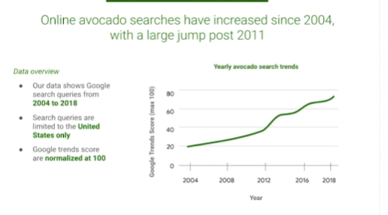

We've got the framework we explored last time and our two data viz examples. According to the McCandless Method, we want to introduce our graphic by name. The name of this graph, "yearly avocado search trends," is clearly written here. When we present it, we'll be sure to share that title with our audience so they know where to focus and what the graphic is all about.

**Second Step of the McCandless Method:** you'll want to answer the obvious questions your audience might have before they're asked.

*Start with the high-level information and work your way into the lowest level of detail that's useful to your audience.*

This way, your audience won't get distracted trying to understand something that could have easily been answered when the graphic was introduced. We added in the information about when, where, and how this data was gathered to frame this data viz.

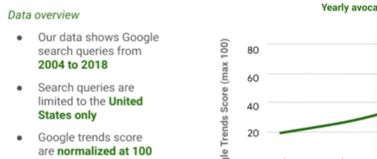

But it also answers the first question many stakeholders will ask, **"Where is this data from, and what does it cover?"**

So going back to the second graph in our presentation, let's think about some obvious questions our audience might have when they see this graph at first.

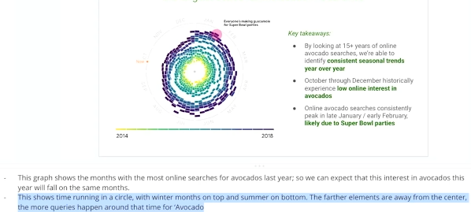

This data viz is really interesting, but it can be hard to understand at a glance, so our audience might have questions about how to read it. Knowing that, we can add an explanation to our speaker notes to answer these questions as soon as this graph is introduced.

Once you've answered any potential questions your audience might have, you'll want to state the insight your data viz provides (it's important to get everyone on the same page before you move into the supporting details), that’s the **third step of the McCandless Method**.

We can write in some key takeaways to this slide to help our audience understand the most important insights from the graphic. Here we let the audience know that this data shows us a consistent seasonal trend year over year. We can also see that there's low online interest in avocados from October through December. This is an important insight that we definitely want to share.

Even though avocados are a seasonal summer fruit, searches peak in January and February. For a lot of people in the United States, watching the Super Bowl and eating chips with guacamole is popular this time of year. Now our audience knows what takeaways we want them to have before moving on.

**The fourth step in the McCandless Method** is calling out data to support that insight.

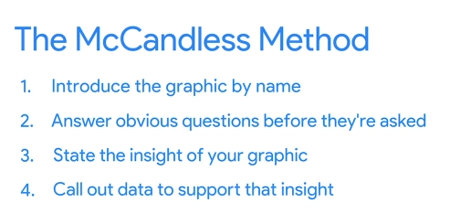

This is your chance to really wow your audience, so give as many examples as you can. With our avocado graphs, it might be worth pointing to specific examples. In our monthly trends graph, we can point to specific weeks recorded here. "During the week of November 25th, 2018, the search score was around 49, but the week of February 4th the search score was 90. This shows the rise and fall of online search interest, with the help of some of the very cool data in our graphs."

Finally, it's time to tell your audience why it matters. **This is the "so what" moment and the Fifth Step of the McCandless Method**.

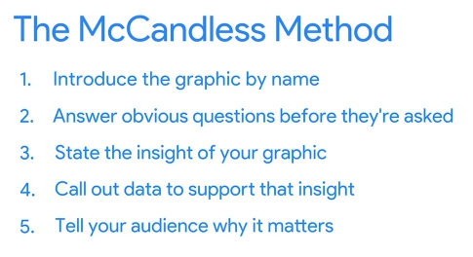

Why is this insight interesting or important to them?

**This is a good time to present the possible business impact of the solution and clear action stakeholders can take**. You might remember that we outlined this in our framework at the beginning of our presentation. So let's explain what this data helps our grocery store stakeholders do.

First, they can account for lower interest in avocados between the months of October and December. They can also prepare for the Super Bowl surge in avocado interest in late January/early February. And they'll be able to consider how to optimize stocking practices during summer and spring. There's a little more detail under each of these points, but this is a basic breakdown of the impact. And that's how we use the McCandless Method to introduce data visualizations during our presentations.

I have one more piece of advice. **Take a second to self-check and ask yourself, "Does this data point or chart support the point I want people to walk away with?" It's a good reminder to think about your audience every time you add data to a presentation**.

So now you know how to present data using a framework, and weave data into your presentation for your audience. And you got to learn the McCandless Method for data presentation. Coming up, we'll learn some best practices for actually creating presentations. See you soon.

[Review a slide presentation](https://www.coursera.org/learn/visualize-data/supplement/FThSi/review-a-slide-presentation)

You have started learning how to create effective slide presentations to share your findings. In this reading, you’ll develop a rubric to help you evaluate slide presentations. By the end of this reading, you will have a stronger understanding of how to create an effective slide presentation using best practices from this course. This will help you evaluate your own work.

## **Your evaluation criteria**

When exploring a slide presentation, use your knowledge of effective presentation practices to evaluate it. This includes reviewing your own work! When you’re checking over slide presentations, there are some best practices you can check for:

* **Include a title, subtitle, and date:** Making sure that your slide deck presentation has a title, subtitle, and date makes sure that your audience knows exactly what you are presenting and when the information was from. That way they know it’s relevant and current to them!
* **Use a logical sequence of slides:** Organizing your slides in an order that makes sense guides your audience through your narrative, building understanding step by step.
* **Provide an agenda with a timeline:** An agenda offers a roadmap of your presentation, allowing your audience to follow along and anticipate key topics.
* **Limit the amount of text on slides:** Keeping text brief ensures clarity and retains the audience’s attention; aim for your audience to scan it within 5 seconds.
* **Start with the business task:** By immediately relating the content to the business task at hand, you contextualize your information, making it relevant and actionable.
* **Establish the initial hypothesis:** Presenting an initial hypothesis gives your audience a starting point for what to expect and frames the subsequent analysis.
* **Show what business metrics you used:** Clarifying which metrics you're analyzing validates your arguments and helps the audience gauge your presentation's relevance to business outcomes.
* **Use visualizations:** Visual aids can illustrate complex data more effectively than text alone, making your message more accessible.
* **Introduce the graphic by name:** A brief introduction to each graphic aids in understanding and retaining information.
* **Provide a title for each graph:** Titles act as signposts, helping the audience quickly grasp the meaning of each visual.
* **Go from the general to the specific:** Starting with a broad overview before diving into details ensures that all audience members are on the same page.
* **Use speaker notes to help you remember talking points:** Notes act as your cue cards, enabling a smoother delivery and ensuring no critical point is missed.
* **Include key takeaways:** Summarizing the main points at the end of your presentation reinforces the message and ensures the audience leaves with the intended takeaways.

Like so many parts of your job as a data professional, creating presentations is an iterative process. Reviewing your work, making changes as needed, and improving it when you can will make your presentations clearer and more useful for stakeholders.

## **Create an evaluation table**

Now that you have an understanding of what best practices you are trying to apply to slide presentations, organize your reviews using an evaluation table. An evaluation table essentially gives you a checklist for each slide in a presentation so you can identify any changes that need to be made in an organized fashion. The evaluation table should have a column for the slide number, a column for you to take notes on what worked well, and a column for what could be improved. Here’s an example of a blank evaluation table: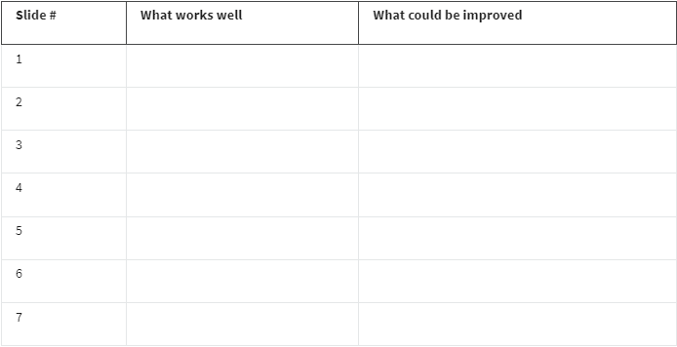

You can use evaluation tables to note things you liked about a presentation as well as things you would like to improve!

## **Key takeaways**

Refining your skills in evaluating slide decks is an evolving journey. Each aspect of your presentation—from a concise title to a coherent sequence of content, and the conciseness of your text to the accuracy of your visuals—is intentionally designed to elevate the audience's understanding and interest. Documenting your progress and taking time for reflection supports your development and is fundamental to communicating complex data in a clear, impactful narrative. And to improve your presentation skills for the future!

[Brittany: Presentation skills for new data analysts](https://www.coursera.org/learn/visualize-data/lecture/mjF9z/brittany-presentation-skills-for-new-data-analysts)

My name is Brittany, and I'm an Analytical Lead at Google. One of the tips that I have is to try to **keep things "kindergarten simple."** And what that means is, keep the concepts that you're presenting as simple and as straightforward as possible.

Whenever you enter a room, there are going to be people within that room of varying interest levels, varying knowledge levels. They have different levels of subject matter expertise. Nobody wants to present to a room whose eyes are glazing over. My pet peeve about seeing certain presentations with data is that they often will include what I like to call "eyesore charts." And what an eyesore chart is, it has way too much data, has way too many colors, it just looks busy, and you just really can't figure out what the presenter is actually trying to say.

Another tip that I have is to **make your presentation fun**. So nobody wants to be in a room where you are talking for a full hour, and the only voice that you're hearing is your own. One of the things that I try to do to break it up is I try to think of little fun games or quizzes, or I'll **play a video or ask questions to the audience** just to make sure that they're fully engaged and that they are talking back to me.

Another tip that I try to **incorporate into my presentations is storytelling**. Everybody loves a good story, and when you do it right, you are able to connect and make your audience engage in a way that they probably wouldn't if you weren't telling that story.

The last tip that I have is **make sure that you have an ally in the room**. Oftentimes before I'm giving a really big data presentation, I will find one or two people that I know are going to be in the room and present my content to them ahead of time. And what that does is it allows me to not only get feedback, but it also allows me to make sure that someone else is nodding their head and aligned to the numbers that I'm about to present. And I can't even tell you how many times that I've been in presentations where those allies have really come to my rescue. When the room asks a lot of questions or is potentially trying to poke holes in the analysis, those allies are there to speak up, and they really are going to have your back and lend credibility to what it is that you're presenting.

The most challenging part of my job would be the fact that I am there to convince people to do something that they might not be fully confident that they should be doing. And a lot of times, it takes multiple conversations, multiple rounds of convincing, for someone to actually come around to what I was trying to articulate or get them to do. When you have spent maybe six months or a year building an analysis and building a story and building a narrative for someone to apply to their strategies, and they actually come around and they actually do it, that makes the challenges worth it.

[Step-by-Step: Critique of a presentation](https://www.coursera.org/learn/visualize-data/supplement/EHWS8/step-by-step-critique-of-a-presentation)

This reading provides an orientation of two upcoming videos:

* **Connor: Messy example of a data presentation**
* **Connor: Good example of a data presentation**

To get the most out of these videos, you should watch them together (back to back). In the first video, Connor introduces a presentation that is confusing and hard to follow. In the second video, he returns to talk about what can be done to improve it and help the audience better understand the data and conclusions being shared.

## **Messy data presentation**

In the first video, watch and listen carefully for the specific reasons the “messy” presentation falls short. Here is a preview:

* No story or logical flow
* No titles
* Too much text
* Inconsistent format (no theme)
* No recommendation or conclusion at the end

### **Messy presentation: people don’t know where to focus their attention**

The main problem with the messy presentation is the lack of a logical flow. Notice also how the data visualizations are hard to understand and appear without any introduction or explanation. The audience has no sense of what they are looking at and why. When people in the audience have to figure out what the data means without any help, they can end up being lost, confused, and unclear about any actions they need to take.

## **Good data presentation**

In the second video, numerous best practices are applied to create a better presentation on the same topic. This “good” presentation is so much easier to understand than the messy one! Here is a preview:

* Title and date the presentation was last updated
* Flow or table of contents
* Transition slides
* Visual introduction to the data (also used as a repeated theme)
* Animated bullet points
* Annotations on top of visuals
* Logic and progression
* Limitations to the data (caveats) - what the data can’t tell you

**Tip:** As you watch this video, take notes about what Connor suggests to create a good presentation. You can keep these notes in your journal. When you create your own presentations, refer back to your notes. This will help you to develop your own thinking about the quality of presentations.

### **Good presentation: people are logically guided through the data**

The good presentation logically guides the audience through the data – from the objectives at the beginning all the way to the conclusions at the end. Notice how the data visualizations are introduced using a common theme and are thoughtfully placed before each conclusion. A good presentation gives people in the audience facts and data, helps them understand what the data means, and provides takeaways about how they can use their understanding to make a change or do some good.

## **Up next**

Get started with the messy vs. goodpresentation comparison by viewing the first video: [Connor: Messy example of a data presentation](https://www.coursera.org/learn/visualize-data/lecture/SYW63/connor-messy-example-of-a-data-presentation).

[Connor: Messy example of a data presentation](https://www.coursera.org/learn/visualize-data/lecture/SYW63/connor-messy-example-of-a-data-presentation)

So we're going to dive into specific examples that we have. So we've built what we call a messy example of a data presentation. We'll walk through each slide and the presentation as a whole to understand why it doesn't actually work well for explaining a specific analysis. We have a title slide: "The Relationship Between Health and Happiness Around the World."



Right off the bat, there is a very generic picture about the world. It is a very lengthy title. We know what we're going to be talking about, but there's nothing here that's really compelling about the presentation.

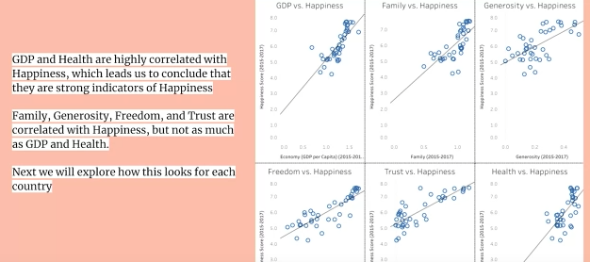

The first slide, when we are looking at a data presentation, we have immediately put a lot of data in front of them and a lot of text in front of them. Right now they don't know what they're looking at. There was no statement of purpose. We don't have an introduction slide. They don't know who I am. They don't know why they're there. What are we talking about? Why are we talking about it? What should they walk away with? There's none of that—we've just immediately gone into the specific data visuals that we are showing them. Now, an important aspect of every slide is also to have a title. Now, title, subtitle, these things help people understand exactly what this slide is going to be discussing so that they know what they're trying to understand as you are talking. So immediately getting here, the audience is going to be lost. They're going to be trying to read the slide. They're going to be trying to decipher what the visuals mean. It's important for you to make sure there's not too much going on. Now if we move on to the next slide, what we're looking at here —the visual is better, it's easier to understand. There's not more than one of them. We have a map. We have visual colors to represent the numeric values within them. But again, there's nothing for them to really understand.

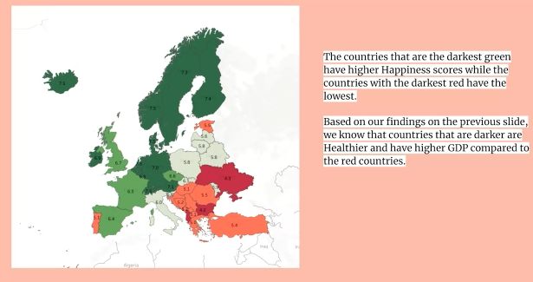

Now this is where you can explain within the speaker notes. But you also have, again, a lot of words, no title. What is it that they are really trying to get from this slide? Part of a good presentation, as well, is the theme that you have or a consistent theme. So you've now switched sides of the specific visual. You have the text on the other side. Doesn't mean you can't do it, but what you're really trying to do throughout a presentation is build some familiarity, especially with data analytics. You're building familiarity with the visuals that you're showing them—the data. By the end of the presentation, they should understand the data or the concept as much as you do.

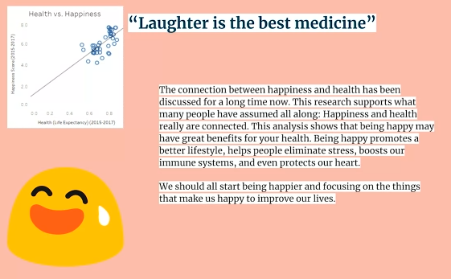

Finally, we have the conclusion slide. This one does have a title: "Laughter is the best medicine." We understand again what it is that we're looking at, but there is no logical flow and how to get here.

Was this overall presentation compelling? We put two slides there. We had too much text. We didn't really explain anything about it. Again, there's awkward placement on where all of these things are within the slide itself. When you're thinking about building a presentation, you should think about it from the audience's point of view. The only thought that's going through their head is, "Where should my focus be? As I'm trying to listen, as I'm trying to comprehend, where should I be looking?" If you have slides like we just showed you, they don't know where they should be looking or they're going to spend their time reading and trying to comprehend while you're also talking. It's very important that you are directing their gaze and directing the audience so that they know exactly what they should be listening to, what they should be trying to understand, and you are guiding them through to the overall conclusion.

So to sum up in terms of what is wrong with this overall presentation and not just what you're going to be talking about or what you are trying to conclude, but just the overall placement of the data visuals and the visuals that you chose.

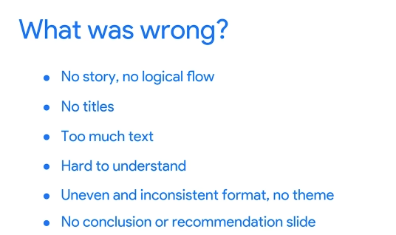

The main thing is there was no story, no logical flow. You started with a bunch of scatterplots and a lot of text and you moved on to the heatmap of the happiness scores, but without somebody presenting something, without any idea of the concept behind what they are trying to conclude. You didn't have titles, there's too much text, it's very difficult to understand, and it was uneven and inconsistent. Even if you had a really good explanation on each slide, you might have lost the audience because what they were trying to do, what they were trying to understand, is what was the slide trying to tell them? Finally, the most important part of any data analytics presentation is the recommendation or conclusion slide. You had that, but there was no title. They didn't know that this was the end of the presentation, that this is where they should be trying to put all the pieces together. Coming up, we're going to discuss how we can improve this presentation, as well as dive into what the presentation will actually look like when we're trying to explain how health and happiness are correlated.

[Connor: Good example of a data presentation](https://www.coursera.org/learn/visualize-data/lecture/ZJP4T/connor-good-example-of-a-data-presentation)

So now that you know what not to do, I'm going to walk you through how I would tackle a presentation.

So to start, you can see the title slide, it's a lot simpler.



We have a title, we have who is presenting, and we have when it occurred.

**Now, I do want to talk a little bit about the date at the bottom, which is an important factor that you shouldn't forget to include**.

You may come back to this presentation a few months later, even a year later or this may be disseminated across your company. **It's important to know when this analysis took place, and why, and what were the circumstances of it?**

And the big part of that is, what were the circumstances of the company at the time that this was actually presented?

So the next slide is giving an idea of what you're going to be presenting to everyone and when.

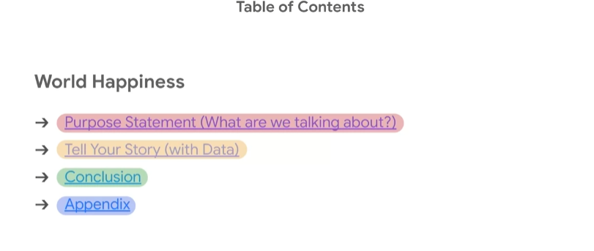

So you start with your purpose statement. What you're going to be discussing, what are we talking about? The next aspect is, where you actually tell your story. And that's an important concept is this overall presentation is a story with data. And finally, you have your conclusion slide. You're going to be very clear that this is the conclusion. This is where you're going to add recommendations if this is in a business context. And then you'll have your appendix, where you can have additional information on data, data visuals, as well as overall context for the presentation that may not work within the overall flow itself.

So, our transition slide, what are we talking about?



So this is where you let the audience know what we're talking about, what are we trying to tell them? What are all the slides that are following this going to be driving towards?

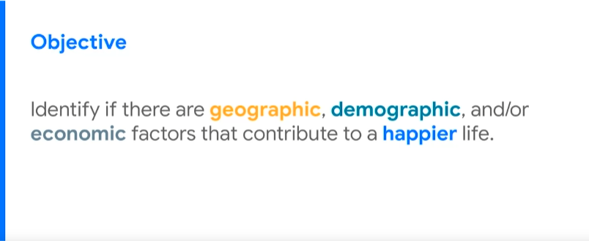

So when we look at this slide, I'm trying to identify if there are geographic, demographic, and/or economic factors that contribute to a happier life. That is the purpose of the overall presentation. So everybody now in the room knows this and that is what they're going to be thinking about as you present all of the data to them.

Next section on our **table of contents**, present the data.



It is important to mention these will probably have different **titles** as you build them out, but this is the topic that we're moving into.

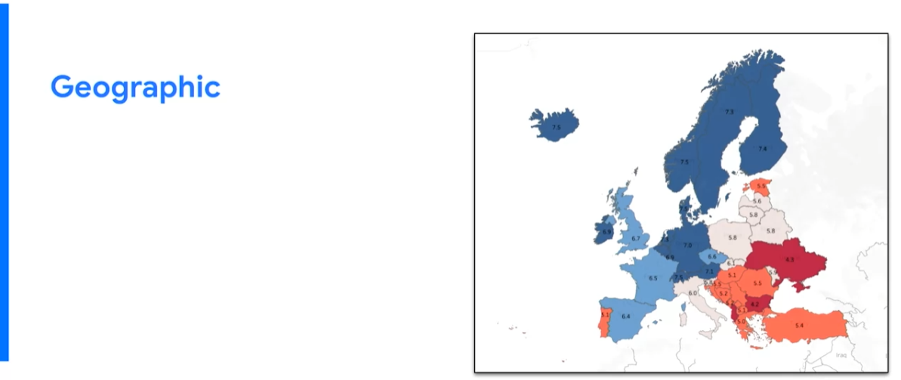

So you'll recognize this visual from the messy slide, but it has a different color context. That's not as important but what is important is when you get here, you have a title on the slide, you have a visual, but there is no text. And this is an important aspect to it is what we're trying to do is walk and introduce the audience to the overall data that you're going to be using.

Now, this is the first slide that has any form of content on it, so it's important that you introduce them to the underlying data.

And seeing as the data is all about geographic, demographic, and economic data points per each country, it's important that the visual represents that. If I were to be the presenter on a slide like this, I would start by getting to this slide and explaining the process and data that we're looking at. So, we analyzed the data set, consisting of data collected from residents of European countries between 2015 and 2017. The data contained demographic and economic data for individuals within each country, including population, GDP, or Gross Domestic Product, and the happiness score per person.

So I've now introduced them to the data set.

There's still no text, so they know that they should be looking at the visual and listening to me.

Now the next aspect which can be over utilized but I've also seen underutilized is using **animations** in your presentation. Animations can be used as a way to direct your audience's attention as you speak. A way to say, look over here at this area of the slide as I'm talking.

It also allows them not to get too bogged down or distracted as you're introducing new concepts to them. Because remember, as you're introducing data the technical components may be new to a lot of people.

And finally, another way to do this is through **annotations** on top of visuals that can be used as another form of directing their gaze and their overall attention. So putting these together, we can have something like an annotation appear as you're discussing it.



So, if we were trying to explain what the visual is showing, we have an annotation that pops up that says "happiness score" and points to the score within the specific country, and we can explain exactly what the visual is showing.

So in this way, we could say something like, we began by creating a heat map of the happiness score for each country. Where the number within each country represents the overall score and the colors represent how high or how low the score is on a scale.

So, the darker blue the country is, the higher the numeric happiness score for that country. The deeper red that the country is, the lower the happiness score and overall numeric value.

So what we've done before any text has appeared on the screen is explain the visual, explain the overall data that they're going to be looking at throughout the presentation, so that they now can understand when we dive into this specific analysis.

So it's important that you only use text on the screen in a short and concise manner to highlight the main points that you're discussing. So after I introduce the visual, I can now dive into the analysis.

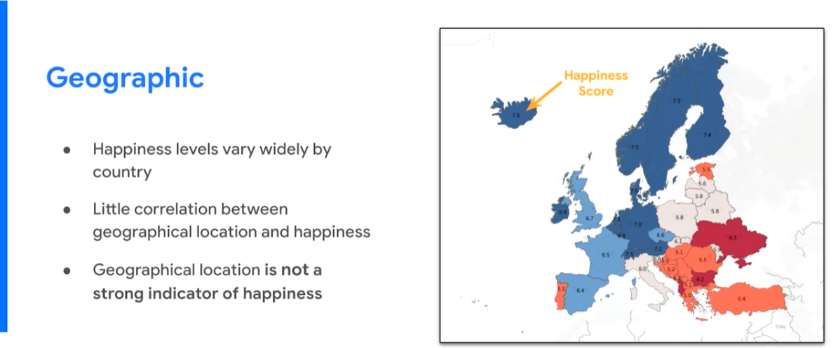 So, we have our first bullet point: Happiness levels vary widely by country. So with this as it appears, my speaker notes can be something along the lines of: "However, as high and low scores are spread sporadically throughout the map, there is little correlation that we find between geographical location and happiness. Finally, we concluded that the geographical location alone was not a strong indicator of happiness."

So as you can see as I'm discussing and as I'm explaining what we are looking at within the data, the overall text on the screen only populated as I began to discuss it, so the audience knew exactly where to look and exactly what to be listening to when I'm talking.

A very important aspect of the flow of the overall presentation is the transition from one slide to the next.

So as I'm discussing this, you can use a bullet point, you can use your speaker notes. Either way, there should be some transition from one slide to the next so that the audience knows that this part is over and they know what's coming next.

So, for this slide, I used my speaker notes. So I'm going to explain the transition, something like: **"Our next step was to identify the demographic and economic differences between the higher and lower countries to isolate the correlated features between them."**

So, we get to the next slide.

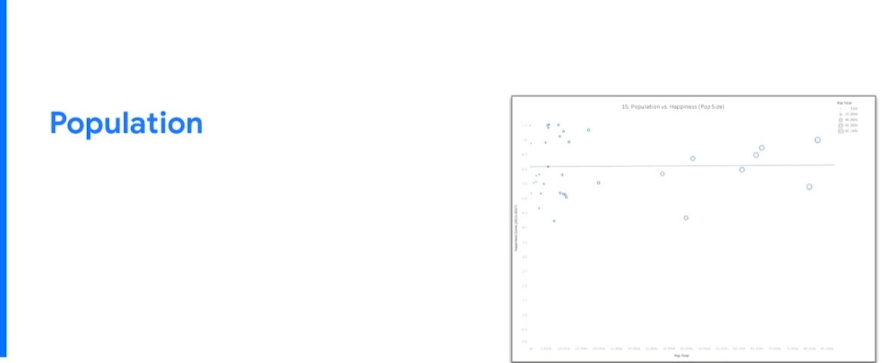

Very common theme, it may be a different visual, but the overall title and where the text is going to show up is going to be in the same place. So we familiarize them with the overall theme of the presentation within three slides.

Now, the title immediately tells what we're going to be discussing.

The previous one was geographic; this one is all based on population.

As we move through this slide and as you saw in the messy example, we use a lot of scatterplots, and scatter plots may not always be the best option because they are rather difficult for people to follow within presentations. But if you explain it to them once so that they understand, you can use them throughout the presentation because you familiarize them. **So, because it's the first time it popped up, it's important that you explain the visual in-depth and all the features of it that you will be talking about later throughout the presentation**. We use animations again. We talk about what are the axes on the scatterplot.

We created a scatterplot in which we plotted countries based on their happiness score and the population to see if there was a correlation between the two.

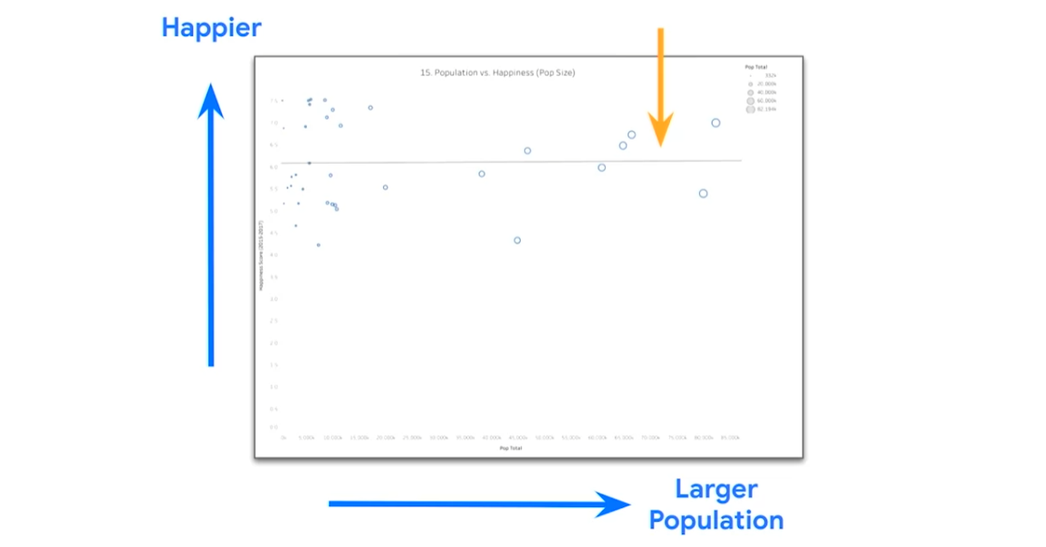

The higher up something is on the scatterplot, the happier the country is. The further to the right that the country is plotted, the larger the population. And **the line that goes between the two is** **testing for correlation** or if these two different points are related to one another.

So these annotations and these animations are there to clarify what the chart is plotting.

Now, the overall purpose is that we are attempting to identify if there is a relationship between the population size of the country and the overall happiness score.

So, now that you have explained what this visual is, you can now dive into the results of it.

Now this slide itself has one bullet point.

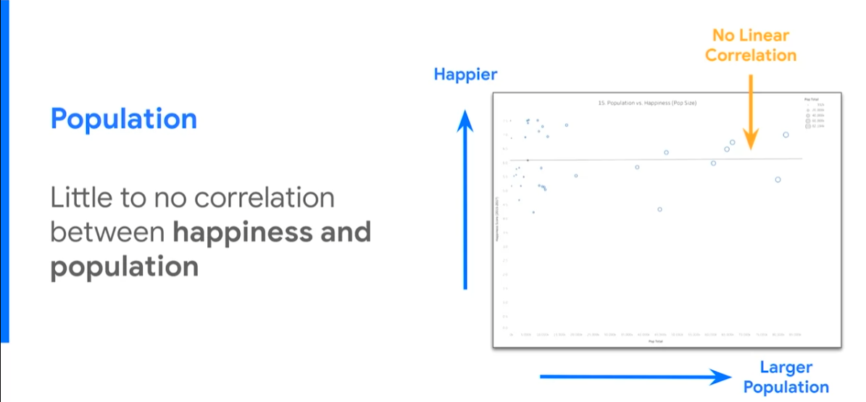

It is the results of the overall analysis that you can find just based on the data visual. We found that there was little to no correlation between happiness and population based on the analysis that we ran. So all discussion and in-depth explanation of the visual is kept in the speaking notes besides the overall annotations.

And again, the transition is very important to the next slide. So, you can say something like: "So next, we dove into the specific demographics of each country to see if we can identify the features that separate or correlate with the overall happiness of the country."

Again, same thing. We have the title, we know what we're going to be talking about now. This is how the health of each country and how it correlates with happiness.

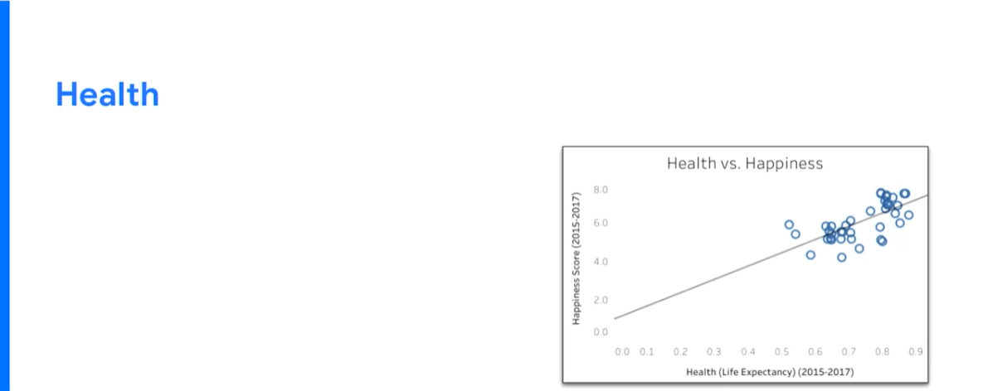

We have a scatterplot again, except the good news is, you've already introduced what the scatterplot is and what you are comparing there. So now the audience has been familiarized with the data set. You don't have to go through and explain exactly what the visual is representing. You can dive into the overall differences or analysis that you're going to be presenting on this slide. You can have something explaining that we found a positive correlation between happiness and health, or overall life expectancy of the country.

Now we found this because the correlation coefficient between the two different factors being happiness and health was 0.50.

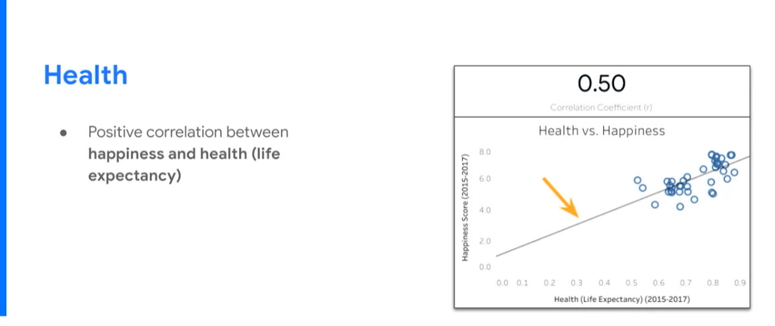

Now, you just introduced a new concept. This is where you have to now explain the new concept because otherwise you may lose people in the room. This is a technical component to your overall analysis and it is an important component so it is critical that you do explain what it is, but in a simplified way so that everybody understands.

So, you can say something along the lines of: "A correlation coefficient is a measure of strength and direction of the linear relationship between two variables. So in other words, the closer to one that the number is, the more positively correlated they are. Meaning, when one of the variables goes up, so does the other one. The closer to the negative one that the number is, the more negatively correlated they are. Meaning, as one of the variables, such as happiness, goes up that the other variable like health would go down. And the closer to zero it is, it means they are not correlated at all, which is what we saw between population and happiness, and means that they have no relationship together."

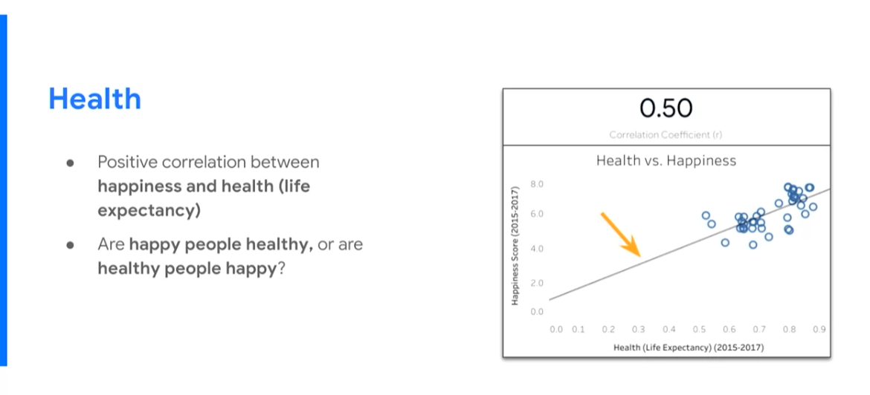

So we've now explained exactly what it is that we use as an analysis on this specific slide. And it's important again that we discuss the transition to the next. So: "We did find that there is a positive correlation between happiness and health, but the question remains, are happy people healthy or are healthy people happy? We know that they are related but we don't know what causes the other. And finally, what contributes to a longer life expectancy? If we know that longer life expectancy is related to happiness, what is it that helps create longer life expectancy within a country?" Now these are the two questions that we need to answer before the end of the presentation moving on from here.

So again, we are creating a logical flow as we move through this presentation.

Now, we are looking at a new concept: wealth within each country.

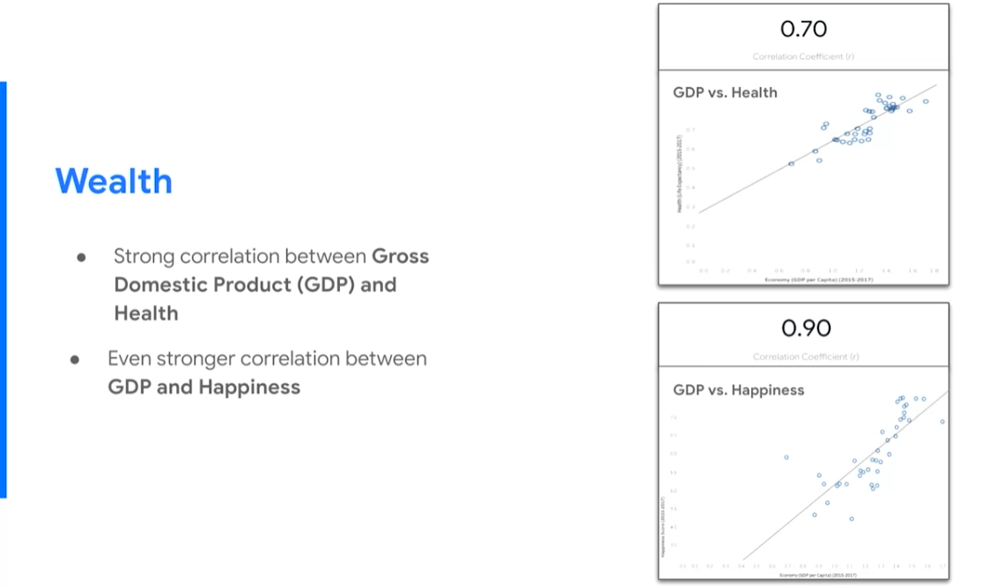

Now that you are using things such as the scatterplot are familiar with the audience, it's okay now that you add in additional ones. So, you can say something along the lines of: "We then analyzed how GDP or the overall economic status of the country relates to the overall health of the country. Because if we know that GDP is related to health and we know that health is related to happiness, then we can infer additional information through that. So, we found that there is a strong correlation between gross domestic product and the overall health of a specific country with a 0.7 correlation coefficient, so higher than the overall correlation coefficient for health and happiness. Next we found an even stronger correlation between GDP and happiness. So, whereas we first looked at health and happiness and then GDP and health, we're now looking at GDP and happiness and found that it has the highest correlation coefficient between all three of those comparisons.

So we have a conclusion within just this slide, which is, we found that richer countries have a higher average happiness level."

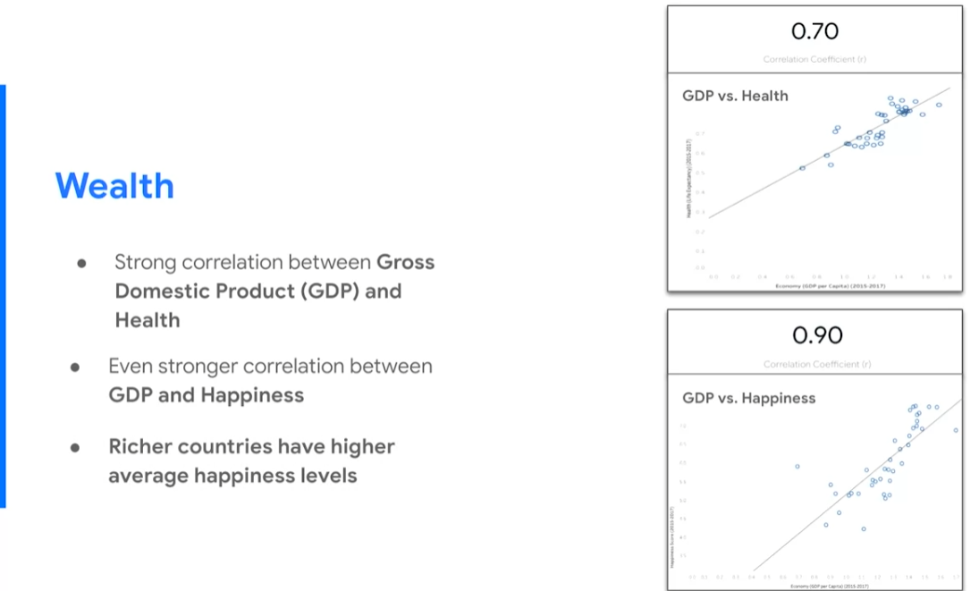

This is a good transition to the overall conclusion of your entire presentation.



So again, you're directing your audience through just presenting the text that you want them to look at.

Your first conclusion from your overall presentation. Wealthier countries and ones that have sustained economic growth tend to have a higher average happiness level.

Your second conclusion: healthier countries also tend to have a happier population. However, healthier countries also tend to be wealthy.

And finally, this is where you take it home.

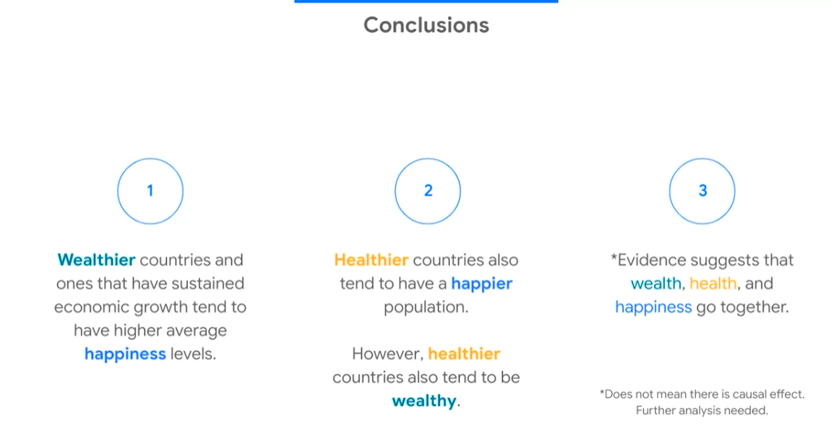

So our evidence suggests that wealth, health, and happiness all go together. It's important to also discuss any caveats or future analysis that needs to be run to answer the questions that may come up based on this analysis. "So we have said that the evidence suggests that wealth, health, and happiness all go together, but that does not mean that one causes the other, So there needs to be future analysis to understand any causal effects between them."

And then you have your final slide, and this is where questions would come in.



So it's important to remember that data storytelling is an art. What we've given you is some high-level overview and examples of what not to do and an improved version, but don't be afraid to put yourself in there.

The overall presentation style is going to come from your personality and skill set within data analytics. You can use the tools that we use to help you build the layout of your presentation, but it's up to you to really put a lot of yourself into it, and a lot of your own skills to help people understand the overall analytics that you've run.

PRESENTATION SKILLS AND PRACTICES

[Proven presentation tips](https://www.coursera.org/learn/visualize-data/lecture/EKyBG/proven-presentation-tips)

So far we've learned about using a framework to guide your audience through your presentation and how to weave data in.

Now I want to talk about why these presentation skills are so important and give you some simple tips you can use during your own presentations.

As a data analyst, you have **two key responsibilities:** analyze data and present your findings effectively.

Analyzing data seems pretty obvious. It's in the title "data analyst," after all.

But data analysis is all about turning raw information into knowledge. If you can't actually communicate what you've learned during your analysis, then that knowledge can't help anyone.

There's plenty of ways data analysts communicate: emails, memos, dashboards, and of course, presentations. Effective presentations start with the things we've already talked about, like creating effective visualizations and organizing your slides, but how you deliver those things can make a big difference in how well your audience understands them. You want to make sure they leave your presentation empowered by the knowledge and ready to make decisions based on your analysis.

That's why strong presentation skills are so important as a data analyst. If the idea of giving a presentation makes you nervous, don't worry—a lot of people feel that way. **Here's a secret: it gets easier the more you practice.**

Now let's look at some tips and tricks you can use when giving your presentations. We'll go over some more advanced ones later, but let's start with the basics for now.

It's natural to feel your adrenaline levels rise before giving a presentation.

That's just because you're excited to be there. To help keep that excitement in check, **try taking deep, controlled breaths to calm your body down**. As a bonus, this will also help you channel all that excitement into a presentation style that shows your passion for the work you've done. You might remember we talked earlier about using the **McCandless Method** to present data visualizations. Well, it's also a good rule of thumb for presentations in general.

**Start with the broader ideas, the obvious questions your audience might have, and what they need to understand to put your findings in context**. Then you can get more specific about your analysis and the insights you've uncovered.

Let's go back to our avocado example and imagine how we'd start that presentation.

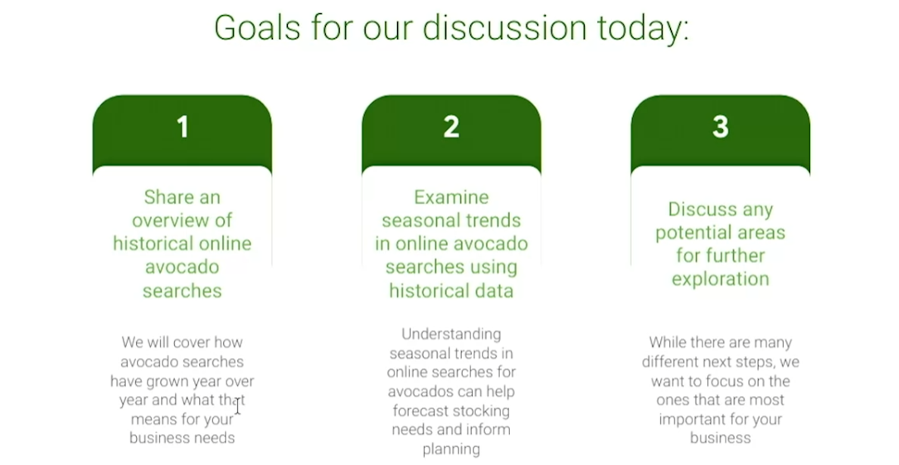

After we introduce ourselves and the title of our presentation, we have a slide with our goals for the discussion. We start with the most general goals and then get more specific.

We might say our goal for today is to first provide you all with the state of the world on online avocado searches.

Then we'll examine the opportunities and risks of seasonal trends in online avocado searches. We'll move into actionable next steps that can help you start taking advantage of these opportunities, as well as help to mitigate the risks.

Finally, we'd love to make the third part a discussion with you about what you think of these next steps.

**What you'll want to notice here is how our presentation focuses on the general interest in avocados online before getting into specifics about what that means for our stakeholders**.

We also learned about the **five-second rule**. As a quick refresher, **whenever you introduce a data visualization, you should use the five-second rule and ask two questions**. First, wait five seconds after showing a data visualization to let your audience process it, then ask if they understand it. If not, take time to explain it, then give your audience another five seconds to let that sink in before telling them the conclusion you want them to understand. Try not to rush through data visualizations. This will be the first time some of the people in your audience are encountering your data, and it's worth making time in your presentations for them.

Here's our first data viz in the avocado presentation.

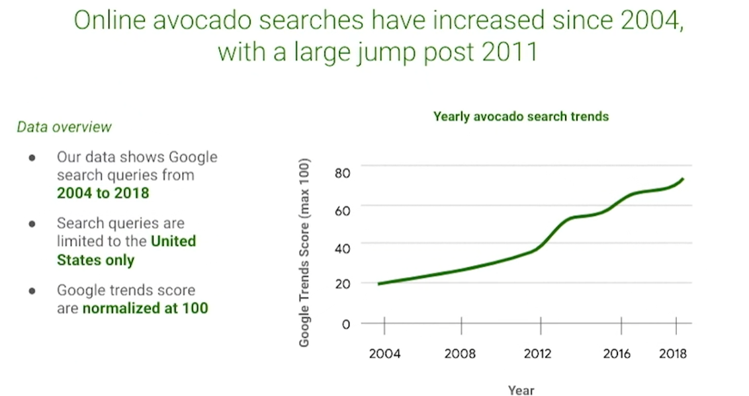

When we get to this slide, we want to introduce our yearly avocado search trends graph and explain the basic background we've included here. After we wait five seconds, we can ask, "Are there any questions about this graph?" Let's say one of our stakeholders asks, "Could you explain Google search trends?" Great.

After explaining that, we wait another five seconds, then we can tell them our conclusion: Searches for avocados have been increasing every year.

You'll learn more about these concepts later on, but these are some great tips for starting out.

Finally, when it comes to presenting data, preparation is key. For some people, that means doing dress rehearsals. For others, it means writing out a script and repeating it in their head. Others find visualizing themselves giving the presentation helps. Try to find a method that works for you. The most important thing to remember is that the more prepared you are, the better you'll perform when the lights are on and it's your turn to present. Coming up, we'll cover more best practices for presentations and also look at some examples. Looking forward to it.

[Self-Reflection: Examples of great presentations](https://www.coursera.org/learn/visualize-data/quiz/p7SVL/self-reflection-examples-of-great-presentations)



## **Activity Overview**



This self-reflection will help you develop insights into your own learning and prepare you to apply your knowledge of presentation best practices to your own presentations. As you answer questions—and come up with questions of your own—you will refine your understanding and reinforce your learning.

You’ve done the hard work, so make sure to get the most out of it: This reflection will help your knowledge stick!

### Step-By-Step Instructions

Follow the instructions to complete each step of the activity. Then answer the question at the end of the activity before going to the next course item.

### Step 1: Review the McCandless Method

As you look at examples in the next section of this activity, ask yourself: How do these presentations use the McCandless method?

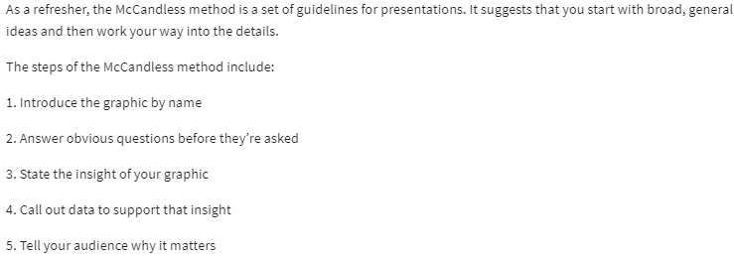

### Step 2: View examples of great spoken presentations

TED Talks are short, spoken messages with important ideas. Take some time to watch the three TED talks linked below, which were carefully selected as model examples of great presentations. As you watch the videos, ask yourself how they each show characteristics of an effective presentation:

1. [The 3 bones of networking](https://www.youtube.com/watch?v=4OTPJZnBP8s)
2. [Grit: The power of passion and perseverance](https://www.youtube.com/watch?v=H14bBuluwB8)
3. [Looking for a job? Highlight your ability, not your experience](https://www.youtube.com/watch?v=guXxy8LH2QM)

### Step 3: View examples of great slide deck presentations

Click the following links to see excellent examples of slide deck presentations. As you view each deck, ask yourself which characteristics of the slide deck make the presentation so effective.

1. [Demystifying value: The importance of lifetime value](https://docs.google.com/presentation/d/1jyZeBt2PizsVU4KdODvzAnUbcz7CIOq6Udvp0d5_jKs/template/preview?resourcekey=0-2M-Yk3_73NwAVg-PaLfvVA) (make a copy or download from the file below)

2. [Airbnb pitch deck from 2008](https://www.failory.com/pitch-deck/airbnb)

[Guide: Share data findings in presentations](https://www.coursera.org/learn/visualize-data/supplement/LFLIP/guide-share-data-findings-in-presentations)

Use this guide to help make your presentation stand out as you tell your data story. Follow the recommended tips and slide sequence in this guide for a presentation that will truly impress your audience.

You can also **download this guide as a .pdf**, so you can reference it in the future:

[Sharing your data findings in presentations _ Tips and Tricks.pdf](https://d3c33hcgiwev3.cloudfront.net/_LwuiIoNSYq8LoiKDUmKxw_e8ff903b66b943ddaea3b8517fe8a3af_Sharing-your-data-findings-in-presentations-_-Tips-and-Tricks.pdf?Expires=1716336000&Signature=c9P7nl4zsJvHTK9AsTqwr9~tISDr7uaf9gRqAU-a1VA-pzjpii4Pn1LnRH6nlK-X-lHJPuwqN6gzTO2a07vwbN~BV7BEwj~jeCfUdz01LiAN95KV48g8oNKug58dr69qWNrJpRVieHvDuGQ~1GQRIzrq9xUgpW7xajgwu3kYmfs_&Key-Pair-Id=APKAJLTNE6QMUY6HBC5A)

## **Telling your data story (tips and tricks to present your data and results)**

Use the following tips and sample layout to build your own presentation.

## **Tip 1: Know your flow**

Just like in any good story, a data story must have a good plot (theme and flow), good dialogue (talking points), and a great ending or big reveal (results and conclusions). One flow could be an overview of what was analyzed followed by resulting trends and potential areas for further exploration.

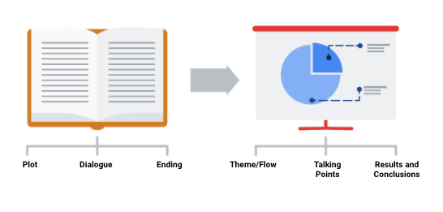

In order to develop the right flow for your presentation, keep your audience in mind. Ask yourself these two questions to help you define the overall flow and build out your presentation.

**Who is my audience?**

* If your intended audience is executives, board members, directors, or other C-level (C-Suite) executives, your storytelling should be kept at a high level. This audience will want to hear about your story but might not have time to hear the *entire* story. Executives tend to focus on endings that encourage improving, correcting, or inventing things. Keep your presentation brief and spend most of your time on your results and recommendations. Refer to an upcoming topic in this reading—Tip 3: end with your recommendations.
* If your intended audience is stakeholders and managers, they might have more time to learn about how you performed your analysis and they might ask more data-specific questions. Be prepared with talking points about the aspects of your analysis that led you to your final results and conclusions.
* If your intended audience is other analysts and individual contributors, you will have the most freedom—and perhaps the most time—to go more deeply into the data, processes, and results.

**What is the purpose of my presentation?**

* If the goal of your presentation is to request or recommend something at the end, like a sales pitch, you can have each slide work toward the recommendations at the end.
* If the goal of your presentation is to focus on the results of your analysis, each slide can help mark the path to the results. Be sure to include plenty of breadcrumbs (views of the data analysis steps) to demonstrate the path you took with the data.
* If the goal of your presentation is to provide a report on the data analysis, your slides should clearly summarize your data and key findings. In this case, it is alright to let the data be the star or speak for itself.

### 

### **Tip 2: Prepare talking points and limit text on slides**

As you create each slide in your presentation, prepare **talking points** (also called **speaker notes**) on what you will say.

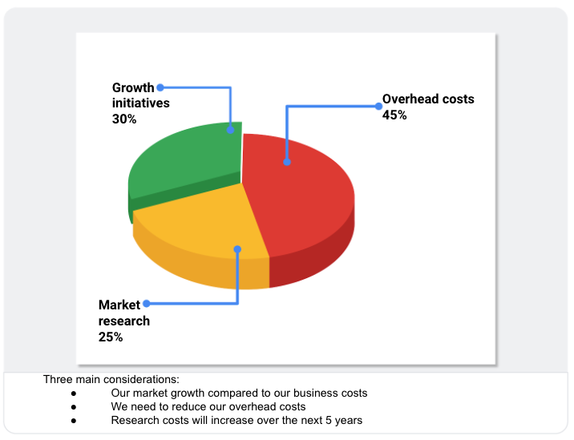

Don’t forget that you will be talking at the same time that your audience is reading your slides. If your slides start becoming more like documents, you should rethink what you will say so that you can remove some text from the slides. Make it easy for your audience to skim read the slides while still paying attention to what you are saying. In general, follow the five-second rule. Your audience should not be spending more than five seconds reading any block of text on a slide.

Knowing exactly what you will say when explaining each slide throughout your presentation also creates a natural flow to your story. Talking points help you avoid awkward pauses between topics. Slides that summarize data can also be repetitive (and boring). If you prepare a variety of interesting talking points about the data, you can keep your audience alert and paying attention to the data and its analysis.

### **Tip 3: End with your recommendations**



When climbing a mountain, getting to the top is the goal. Making recommendations at the end of your presentation is like getting to the mountaintop.

* Useone slide for your recommendations at the end. Be clear and concise.
* If you are recommending that something be done, provide next steps and describe what you would consider a successful outcome.

### 

### **Tip 4: Allow enough time for the presentation and questions**



Assume that everyone in your audience is busy. Keep your presentation on topic and as short as possible by:

* Being aware of your timing. This applies to the total number of slides and the time you spend on each slide.
* Presenting your data efficiently. Make sure that every slide tells a unique and important part of your data story. If a slide isn’t that unique, you might think about combining the information on that slide with another slide.
* Saving enough time for questions at the end or allowing enough time to answer questions throughout your presentation.

### **Putting it all together: Your slide deck layout**

In this section, we will describe how to put everything together in a sample slide deck layout.

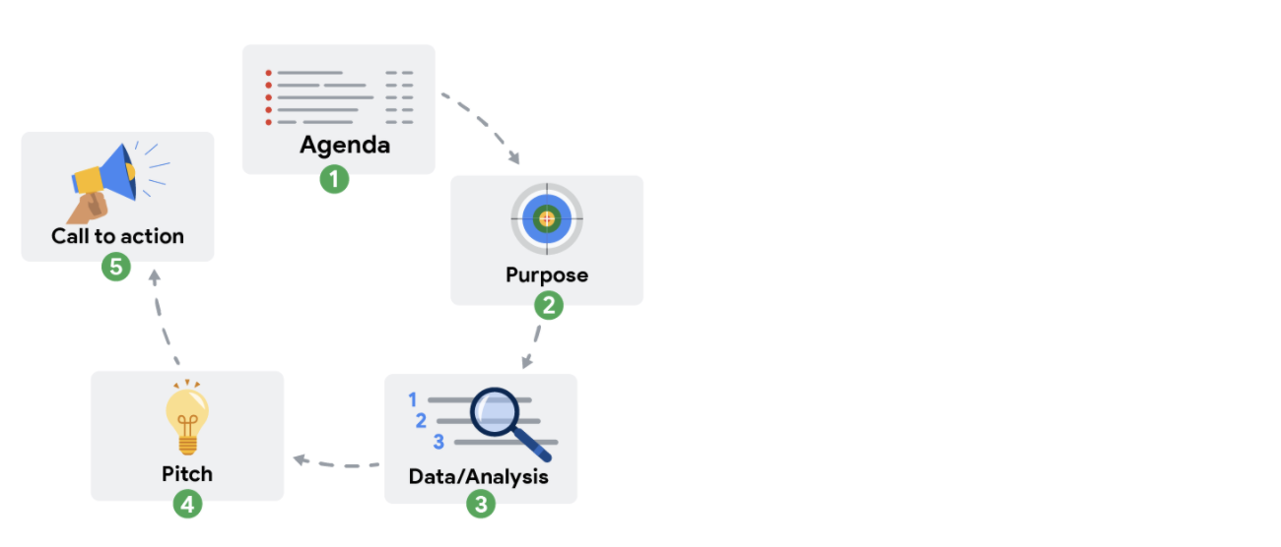

### **First slide: Agenda**

Provide a high-level bulleted list of the topics you will cover and the amount of time you will spend on each. Every company’s norms are different, but in general, most presentations run from 30 minutes to an hour at most. Here is an example of a 30-minute agenda:

* Introductions (4 minutes)
* Project overview and goals (5 minutes)
* Data and analysis (10 minutes)
* Recommendations (3 minutes)
* Actionable steps (3 minutes)
* Questions (5 minutes)

### **Second slide: Purpose**

Everyone might not be familiar with your project or know why it is important. They didn’t spend the last couple of weeks thinking about the analysis and results of your project like you did. This slide summarizes the purpose of the project and why it is important to the business for your audience.

Here is an example of a purpose statement:

*Service center consolidation is an important cost savings initiative. The aim of this project was to determine the impact of service center consolidation on customer response times.*

### 

### **Third slide: Data/analysis**

First, It really is possible to tell your data story in a single slide if you summarize the key things about your data and analysis. You may have supporting slides with additional data or information in an appendix at the end of the presentation.

But, if you choose to tell your story using more than one slide, keep the following in mind:

* Slides typically have a logical order (beginning, middle, and end) to fully build the story.
* Each slide should logically introduce the slide that follows it. Visual cues from the slides or verbal cues from your talking points should let the audience know when you will go on to the next slide.
* Remember not to use too much text on the slides. When in doubt, refer back to the second tip on preparing talking points and limiting the text on slides.
* The high-level information that people read from the slides shouldn’t be the same as the information you provide in your talking points. There should be a nice balance between the two to tell a good story. You don’t want to simply read or say the words on the slides.

For extra visuals on the slides, use animations. For example, you can:

* Fade in one bullet point at a time as you discuss each on a slide.
* Only display the visual that is relevant to what you are talking about (fade out non-relevant visuals).
* Use arrows or callouts to point to a specific area of a visual that you are using.

### **Fourth slide: Recommendations**

If you have been telling your story well in the previous slides, the recommendations will be obvious to your audience. This is when you might get a lot of questions about how your data supports your recommendations. Be ready to communicate how your data backs up your conclusion or recommendations in different ways. Having multiple words to state the same thing also helps if someone is having difficulty with one particular explanation.

### **Fifth slide: Call to action**

Sometimes the call to action can be combined with the recommendations slide. If there are multiple actions or activities recommended, a separate slide is best.

Recall our example of a purpose statement:

*Service center consolidation is an important cost savings initiative. The aim of this project was to determine the impact of service center consolidation on customer response times.*

Suppose the data analysis showed that service center consolidation negatively impacted customer response times. A call to action might be to examine if processes need to change to bring customer response times back to what they were before the consolidation.

### **Wrapping it up: Getting feedback**

After you present to your audience, think about how you told your data story and how you can get feedback for improvement. Consider asking your manager or another data analyst for candid thoughts about your storytelling and presentation overall. Feedback is great to help you improve. When you have to write a brand new data story (or a sequel to the one you already told), you will be ready to impress your audience even more!

[Evaluate your presentation](https://www.coursera.org/learn/visualize-data/supplement/igsQe/evaluate-your-presentation)

Earlier in this course, you practiced creating, giving, and evaluating your own presentation for the [Hands-on Activity: Presenting practice](https://www.coursera.org/learn/visualize-data/quiz/uLhnv/hands-on-activity-presenting-practice). You also learned some best practices for slide presentations and how you can evaluate presentations using them. In this reading, you will take a moment to reflect on how much your presentation skills have developed and create a presentation checklist for yourself to use in the future. This will help you prepare for future presentations as a data analyst and give you a tool to review your own work.

## **Presentation evaluation checklist**

The ability to deliver compelling presentations is just as important as your analyses. Consider your presentation skills and how integral they are to your professional growth. Each time you present, you're not just sharing data; you're telling its story. This requires clear, jargon-free language, especially when addressing an audience not specialized in data analysis. A well-crafted presentation bridges the gap between complex data and actionable insights.

You can enhance your presentation skills by using a presentation checklist. Use it as a personal guide to ensure your message is delivered clearly and effectively. The checklist can be tailored to meet your style and objectives to ensure that it resonates with your audience.

## **Create your own checklist**

As you review your presentation style, focus on the clarity and engagement of your content. Incorporate visuals that complement your narrative and use pauses to let your insights sink in. Every piece of feedback is valuable, offering you a chance to learn and improve. Treat your presentation like a dialogue, not a monologue, and tailor it to foster a connection with your audience.

While using your presentation checklist, pay attention to the effectiveness of your visual aids. They should not only represent data accurately but also highlight the key takeaways in a manner that reinforces your message. Through critical self-review, use this checklist to refine both your verbal and visual communication, turning data into compelling stories. Here are some questions you can incorporate into your checklist:

* Do I use an attention-grabbing opening?
* Do I start with broad ideas and later talk about specific details?
* Do I speak in short sentences?
* Do I pause for five seconds after showing a data visualization?
* Do I pause intentionally at certain points?
* Do I keep the pitch of my sentences level?
* Do I stand still and move with purpose?
* Do I have good posture?
* Do I look at my audience (or camera) while speaking?
* Do I keep my message concise?
* Do I end by explaining to my audience why the data analysis matters?

You can also add checklist items that help you refine your slide deck:

* Do I include a good title and subtitle that describes what I’m about to present?
* Do I include the date of my presentation or the date when my slideshow was last updated?
* Does my font size let the audience easily read my slides?
* Do I showcase what business metrics I used?
* Do I include effective visuals (like charts and graphs)?

## **Key takeaways**

Embracing a cycle of practice, feedback, and refinement underpins professional development in data analysis. A well-crafted presentation checklist can be a key growth accelerator, helping you present complex data simply and captivating your audience. Make it a habit to use this checklist to evaluate your work and welcome constructive criticism. Approach every presentation as a chance to improve your ability to tell a compelling story and become a more skilled and persuasive communicator.

[Present like a pro](https://www.coursera.org/learn/visualize-data/lecture/uJwZx/present-like-a-pro)

Hey, good to see you again. By now you've learned some ways to organize and incorporate data into your presentations.

You've also covered why effective presentation skills are so important as a data analyst. Now you're ready to start presenting like a pro.

Coming up, I'll share some pro tips and best practices with you. Let's get started. We've talked about how important your audience is throughout this program, and it's especially important for presentations. It's also important to remember that not everyone can experience your presentations the same way.

Sharing your presentation via email and putting some forethought into how accessible your data viz is before your presentation can help ensure your work is accessible and understandable. But during the actual presentation, it can be tempting to focus on what's most interesting and exciting to us and not on what the audience actually needs to hear. Sometimes, even the best audiences can lose focus and get distracted, but here's a few things you can do during your final presentation to help you stay focused on your audience and keep them engaged.

First, try to keep in mind that your audience won't always get the steps you took to reach a conclusion. Your work makes sense to you because you did it—this is called the curse of knowledge. Basically, it means that because you know something, it can be hard to imagine your audience not knowing it. **It's important to remember that your audience doesn't have the same context you do, so focus on what information they need to reach the same conclusion you did**. Earlier, we covered some useful things you can add to your presentations to help with this.

First, answer basic questions about where the data came from and what it covers: How is it collected? Does it focus on a specific time or place? You can also include your guiding hypothesis and the goals that drove your analysis. Adding any assumptions or methods you used to reach your conclusions can also be useful. For example, in our avocado presentation, we grouped months by season and looked at overall trends. And finally, explain your conclusion and how you reached it.

Your audience also has a lot on their mind already. They might be thinking about their own work projects or what they want to have for lunch. They aren't trying to be rude, and it doesn't mean they aren't interested; they're just busy people with a lot going on. Try to keep your presentation focused and to the point to keep their minds from wandering. Try not to tell stories that take your audience down into an unrelated line of thinking, and try not to go into too much detail about things that don't concern your audience. You might have found a really exciting new SQL database, but unless your presentation is about databases, you can probably leave that out. Your audience can also be easily distracted by information in your presentation. For example, the more you include in a chart, the more your audience will need to explore it.

Try to avoid including information in your presentations that you don't think will be productive to discussions with your audience, sharing the right amount of content to keep your audience focused and ready to take action. It's also good to note that how you present information is just as important as what you present, and I have some best practices for delivering presentations.

First, pay attention to how you speak. **Keep your sentences short**. Don't use long words where short words will work. Build in intentional pauses to give your audience time to think about what you've just said.

**Try to keep the pitch of your sentences level** so that your statements aren't confused for questions.

Also, **try to be mindful of any nervous habits you have**. Maybe you talk faster, tap your toes, or touch your hair when you're nervous. That's totally normal—everyone does—but these habits can be distracting for your audience.

**When you're presenting, try to stay still and move with purpose**. Practice good posture and make positive eye contact with the people in your audience.

Finally, remember that you can practice and improve these skills with every presentation. Accept and seek out feedback from people you trust. **Feedback is a gift and an opportunity to grow**.

With that, you've completed another module. The presentation skills you've learned here, like using frameworks, weaving data into your presentation, and best practices you can apply during your actual presentations, are going to help you communicate your findings with audiences effectively.

[Test your knowledge on presentation skills and practices](https://www.coursera.org/learn/visualize-data/quiz/3Py4U/test-your-knowledge-on-presentation-skills-and-practices)

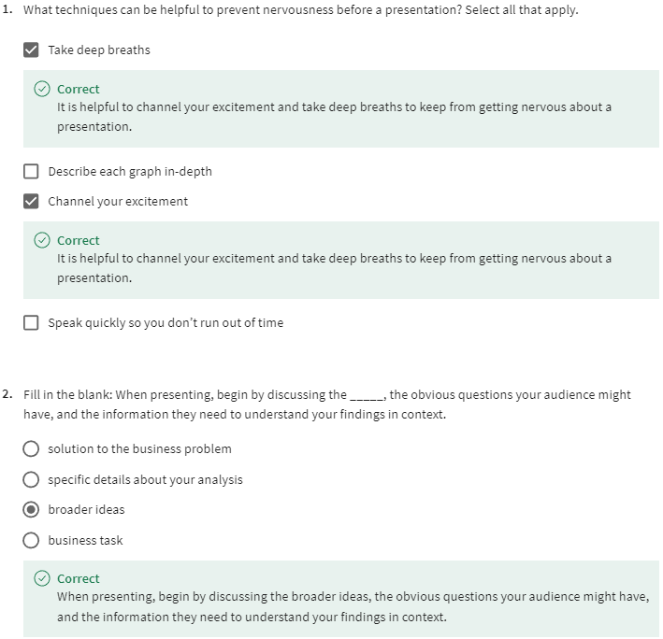

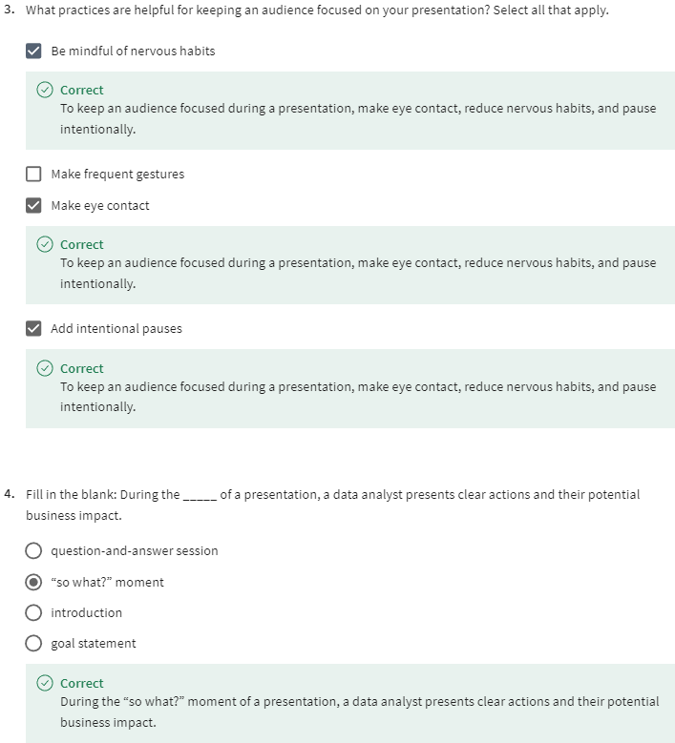

DATA CAVEATS AND LIMITATIONS

[Prepare for the Q&A](https://www.coursera.org/learn/visualize-data/supplement/RI0Cu/prepare-for-the-q-a)

A question-and-answer session, or Q&A, is a valuable opportunity for stakeholders and audience members to ask you any questions they might have about your findings. They can be challenging because you don’t always know what to expect, they require purposeful listening, and it's challenging to keep everyone involved. So, in this part of the course, you will discover some best practices to help you master the Q&A.

In this reading, you will work on the first step: preparing questions to ask **before** planning your data gathering and presentation. There are many things to consider before you begin asking and answering possible questions—including the objective, stakeholder expectations, and if there are any limitations. Make sure you have everything covered before you begin. The checklist below identifies 10 tasks that you should engage in to be prepared for your Q&A:

## **Before the presentation**

1. Assemble and prepare your questions.
2. Discuss your presentation with your manager, other analysts, or other friendly contacts in your organization.
3. Ask a manager or other analysts what sort of questions were normally asked by your specific audience in the past.
4. Seek comments, feedback, and questions on the deck or the document of your analysis.
5. At least 24 hours ahead of the presentation, try and brainstorm tricky questions or unclear parts you may come across- this helps avoid surprises.
6. It never hurts to practice what you will be presenting, to account for any missing information or simply to calm your nerves.

## **During the presentation**

1. Be prepared to respond to the things that you find and effectively and accurately explain your findings.
2. Address potential questions that may come up.
3. Avoid having a single question derail a presentation and propose following-up offline.
4. Put supplementary visualizations and content in the appendix to help answer questions.



## **Practice makes perfect**

Preparing for a presentation or a meeting doesn’t have to be intimidating. If you invest time into knowing your audience, crafting your notes, doing necessary research and organizing your data, then there is very little reason why your audience will not be engaged, even impressed.

[Anticipate the question](https://www.coursera.org/learn/visualize-data/lecture/wulTO/anticipate-the-question)

Hello. So let's talk about how you can be sure you're prepared for a Q&A.

For starters, knowing the questions ahead of time can make a big difference. You don't have to be a mind reader, but there's a few things you can do to prepare that'll help.

For this example, we'll go back to the presentation we created about health and happiness around the world. We put together these slides, clean them up a bit, and now we're getting ready for the actual presentation.

Let's go over some ways we can anticipate possible questions before our Q &amp; A to give us more time to think about the answers.

Understanding your stakeholder's expectations will help you predict the questions they might ask. As we previously discussed, it's important to set stakeholder expectations early in the project. Keep their expectations in mind while you're planning presentations and Q &amp; A sessions.

Make sure you have a clear understanding of the objective and what the stakeholders wanted when they asked you to take on this project.

For this project, our stakeholders were interested in what factors contributed to a happier life around the world. Our objective was to identify if there were geographic, demographic, and/or economic factors that contributed to a happier life. Knowing that, we can start thinking about the potential questions about that objective they might have. At the end of the day, if you misunderstood your stakeholders' expectations or the project objectives, you won't be able to correctly anticipate or answer their questions. Think about these things early and often when planning for a Q &amp; A.

Once you feel confident that you fully understand your stakeholders' expectations and the project goals, you can start identifying possible questions.

A great way to identify audience questions is to do a test run of your presentation. I like to call this the "colleague test." Show your presentation or your data viz to a colleague who has no previous knowledge of your work, and see what questions they ask you. They might have the same questions your real audience does.

We talked about feedback as a gift, so don't be afraid to seek it out and ask colleagues for their opinions. Let's say we ran through our presentation with a colleague, we showed them our data visualizations, then asked them what questions they had. They tell us they weren't sure how we were measuring health and happiness with our data in this slide. That's a great question. We can absolutely work that information into our presentation. Sometimes the questions asked during our colleague tests help us revise our presentation. Other times, they help us anticipate questions that might come up during the presentation, even if we didn't originally want to build that information into the presentation itself. It helps to be prepared to go into detail about your process, but only if someone asks. Either way, their feedback can help take your presentation to the next level.

Next, it's helpful to start with zero assumptions. Don't assume that your audience is already familiar with jargon, acronyms, past events, or other necessary background information. Try to explain these things in the presentation, and be ready to explain them further if asked. When we showed our presentation to our colleague, we accidentally assumed that they already knew how health and happiness were measured and left that out of our original presentation. Now, let's look at our second data viz. This graph is showing the relationship between health, wealth, and happiness, but includes GDP to measure the economy. We don't want to assume that our audience knows what that means, so during the presentation, we'll want to include a definition of GDP. In our speaker notes, we've added gross domestic product: total monetary or market value of all the finished goods and services produced within a country's borders in a specific period of time.

We'll fully explain what GDP means as soon as this graphic comes up; that way, no one in our audience is confused by that acronym. It helps to work with your team to anticipate questions and draft responses.

Together, you'll be able to include their perspectives and coordinate answers so that everyone on your team is prepared and ready to share their unique insights with stakeholders. The team working on the world happiness project with you probably have a lot of great insights about the data, like how it was gathered or what it might be missing. Touch base with them so you don't miss out on their perspective.

Finally, be prepared to consider and describe to your stakeholders any limitations in your data. You can do this by critically analyzing the patterns you've discovered in your data for integrity. For example, could the correlations found be explained as coincidence? On top of that, use your understanding of the strengths and weaknesses of the tools you use in your analysis to pinpoint any limitations they may have introduced. While you probably don't have the power to predict the future, you can come pretty close to predicting stakeholder and audience questions by doing a few key things. Remember to focus on stakeholder expectations and project goals, identify possible questions with your team, review your presentation with zero assumptions, and consider the limitations of your data. Sometimes, though, your audience might raise objections to the data before and after your presentation. Coming up, we'll talk about the kind of objections they might have and how you can respond. See you next time.

[Handle objections](https://www.coursera.org/learn/visualize-data/lecture/BxgQQ/handle-objections)

We'll talk about how you can handle objections about the data you're presenting. Stakeholders might raise objections during or after your presentation. Usually, these objections are about the data, your analysis, or your findings.

We'll start by discussing what questions these objections are asking and then talk about how to respond. Objections about the data could mean a few different things. Sometimes, stakeholders might be asking where you got the data and what systems that came from, or they might want to know what transformations happened to it before you worked with it, or how fresh and accurate your data is. You can include all this information in the beginning of your presentation to set up the data context.

You can add a more detailed breakdown in your appendix in case there are more questions. When we're talking about cleaning data, you learned keeping a detailed log of data transformations is useful. That log can help you answer the questions we're talking about here, and if you keep it in your presentation's appendix, it'll be easy to reference if any of your stakeholders want more detail during a Q & A. Now, your audience might also have questions or objections about your analysis.

They might want to know if your analysis is reproducible, so it helps to keep a change log documenting the steps you took. This way, someone else could follow along and reproduce your process. You can even create a slide in the appendix section of your presentation explaining these steps, if you think it will be necessary. And it can be useful to keep a clean version of your script if you're working with a programming language like SQL or R, which we'll learn all about later. Also, be prepared to answer questions like, "Who did you get feedback from during this process?" This is especially important when your analysis reveals insights that are the opposite of your audience's gut feelings about the data. Making sure to include lots of perspectives throughout your analysis process will help you backup your findings during your presentation. Finally, you might be faced with objections to the findings themselves.

A lot of the time these will be questions like, "Do these findings exist in previous time periods, or did you control for the differences in your data?" Your audience wants to be sure that your final results accounted for any possible inconsistencies and that they're accurate and useful. Now that you know some of the possible kinds of objections your audience might raise, let's talk about how you can think about responding.

First, it can be useful to communicate any assumptions about the data, your analysis, or your findings that might help answer their questions. For example, did your team clean and format your data before analysis? Telling your audience that can clear up any doubts they might have.

Second, explain why your analysis might be different than expected. Walk your audience through the variables that change the outcomes to help them understand how you got there.

And third, some objections have merit, especially if they bring up something you hadn't thought of before. If that's true, you can acknowledge that those objections are valid and take steps to investigate further. Following up with more details afterwards is great, too. And now you know some of the basic objections you might run into. Understanding that your audience might have questions about your data, your analysis, or your findings can help you prepare responses ahead of time, and walking your audience through any assumptions about the data or unexpected results are great approaches to responding.

Coming up, we'll go over even more best practices for responding to questions during a Q & A.

[Self-Reflection: Practice handling objections](https://www.coursera.org/learn/visualize-data/quiz/zbo1D/self-reflection-practice-handling-objections)



**Activity Overview**

**Empty alt text.**

Now that you have learned about how to handle objections to your data, you can pause for a moment and think about what you are learning. In this self-reflection, you will consider your thoughts about how to respond to objections when giving a presentation and answer brief questions about your approach.

This self-reflection will help you develop insights into your own learning and prepare you to apply your knowledge of handling objections to real-world scenarios. As you answer questions—and come up with questions of your own—you will consider concepts, practices, and principles to help refine your understanding and reinforce your learning. You’ve done the hard work, so make sure to get the most out of it: This reflection will help your knowledge stick!

**Step-By-Step Instructions**

**Step 1: Respond to a business task**

While delivering a presentation to an audience, your primary goal is to respond to a business task. A business task is a question or problem you use data to solve—and a presentation demonstrates how to solve it. Business tasks can have a variety of contexts and scopes, so the details of your presentation will depend on a lot of factors.

Sometimes, you may receive questions or objections about your presentation. This is normal, as your audience wants to understand your presentation as completely as possible. Responding to these questions and objections in a clear, concise, and polite manner is crucial to delivering an effective presentation.

**Step 2: Review examples of objections**

Consider the following situations where a data analyst delivers a presentation and receives an objection:

1. An analyst is presenting on the sales revenue of their company’s new product: an autonomous vacuum cleaning robot. The analyst shows the steps they took for each part of the analysis. They are confident that they have explained each step very thoroughly, but a stakeholder is confused when the presentation is over. They share a concern that the analysis may be incomplete.
2. An analyst is presenting on the effectiveness of a new drug treatment for heartburn. They use data from an external private company that describes how common heartburn is in the United States. After the presentation, they receive an objection from their stakeholder about the data collected. The stakeholder is concerned that the source of the data may not be reputable, and is unsure about the credentials of the data’s source company.
3. An analyst is presenting on the traffic patterns of a particular highway in their city. After extensive research and analysis, they conclude that Friday is the busiest day for commuters on that highway. One of the stakeholders, who commutes along that highway, disagrees and believes that Monday is the busiest day for traffic.

[Test your knowledge on caveats and limitations to data](https://www.coursera.org/learn/visualize-data/quiz/QNVZa/test-your-knowledge-on-caveats-and-limitations-to-data)

LISTEN, RESPOND, AND INCLUDE

[Q&A best practices](https://www.coursera.org/learn/visualize-data/lecture/pA1FW/q-a-best-practices)

Earlier we talked about some ways that you can respond to objections during or after your presentations. In this video, I want to share some more Q & A best practices. Let's go back to our world happiness presentation example. Imagine we finished preparing for a Q & A, and it's time to actually answer some of our audience's questions. Let's go over some ways that we can be sure that we're answering questions effectively. Will start with a really simple one: listen to the whole question. I know this sounds like a given, but it can be really tempting to start thinking about your answer before the person you're talking to has even finished asking their question. On slide 11 of our presentation, we outline our conclusions. After explaining these conclusions, one of our stakeholders asks, "How was happiness measured for this project?" It's important to listen to the whole question and wait to respond until they're done talking. Take a moment to repeat the question. Repeating the question is helpful for a few different reasons. For one, it helps you make sure that you're understanding the question. Second, it gives the person asking it a chance to correct you if you're not. Anyone who couldn't hear the question will still know what's being asked. Plus, it gives you a moment to get your thoughts together. After listening to the question and repeating it to make sure you understand, you can explain that participants in different countries were given a survey that asked them to rate their happiness, and just like that, your audience has a better understanding of the project because you took the time to listen carefully. Now that they know about the survey, they're interested in knowing more. At this point, we can go into more detail about that data. We have a slide built in here called the appendix. This is a great place to keep extra information that might not be necessary for our presentation but could be useful for answering questions afterwards. This is also a great place for us to have more detailed information about the survey data so we can reference it more easily. As always, make sure you understand the context questions are being asked in. Think about who your audience is and what kinds of concerns or backgrounds they might have. Remember the project goals and your stakeholders' interests in them, and try to keep your answers relevant to that specific context, just like you made sure your presentation itself was relevant to your stakeholders. We have this slide with data about life expectancy as a metric for health. If you're presenting to a group of stakeholders who are in the healthcare industry, they're probably going to be more interested in the medical data and the relationship between overall health and happiness. Knowing this, you can tailor your answers to focus on their interests so that the presentation is relevant and useful to them. When answering, try to involve the whole audience. You aren't just having a one-on-one conversation with the person that's asked the question; you're presenting to a group of people who might also have the same question or need to know what that answer is. It's important to not accidentally exclude other audience members. You can also include other voices. If there's someone in your audience or team that might have insight, ask them for their thoughts. Keep your responses short and to the point. Start with a headline response that gives your stakeholders the basic answer. Then if they have more questions, you can go into more detail. This can be difficult as a data analyst. You have all the background information and want to share your hard work, but you don't want to lose your audience with a long and potentially confusing answer. Stay focused on the question itself. This is why listening to the whole question is so important. It keeps the focus on that specific question. Answer the question as directly as possible using the fewest words you can. From there, you can expand on your answer or add color, contexts, and detail as needed. Like when one of our stakeholders asked how the data measuring happiness was gathered. We started by telling them that a survey was used to measure an individual's happiness, and only when they were interested in hearing more about the survey did we go into more detail. To recap, when you're answering questions during a presentation Q & A, remember to listen to the whole question, repeat the question if necessary, understand the context, involve your whole audience, and keep your responses short. Remember, you don't have to answer every question on the spot. If it is a tough question that will require additional analysis or research, it's fine to let your audience know that you'll get back to them; just remember to follow up in a timely manner. These tips will make it easier to answer questions and make you seem prepared and professional. Now that you're presentation-ready, it's time to wrap up. We covered a lot about how to consider questions before a Q & A, how to handle different kinds of objections, and some best practices you can use in your next presentation. That's it for now. See you in the next video.

[Ask for feedback](https://www.coursera.org/learn/visualize-data/discussionPrompt/byLQe/ask-for-feedback)

During a presentation, you should pay special attention to the needs of your audience. In a data analysis setting, your audience will likely include your stakeholders or supervisors. They have a vested interest in the work you’ve done, so it is important to communicate your findings to them as clearly as possible.

At the end of a presentation, you’ll typically be asked to hold a question and answer (Q&A) session. During the Q&A, your audience can ask you for clarification about what you’ve presented or provide advice about how to proceed.

In some cases, you might find that stakeholders don’t know how best to ask a question. Imagine a scenario in which a stakeholder is confused about what you’ve discussed, but is having trouble figuring out how to ask their question in a group setting. With this scenario in mind, consider the following **questions**:

* What are some other ways you can receive feedback from your audience and stakeholders?
* How can you be as inclusive as possible? How can you make your audience feel comfortable asking you for clarification?
* What creative methods can you use to engage your audience?

Submit 3-5 sentences (150-200 words) answering these questions. Then, visit the [discussion forum](https://www.coursera.org/learn/visualize-data/discussions/weeks/4/threads/KSV-e3hyEeuDUBJt31lHdQ) to read what others have written, and respond to at least two posts with your own thoughts.

Participation is optional

**ANSWER:**

What are some other ways you can receive feedback from your audience and stakeholders?

* You can leave your email so they can send you messages inquiring about the analysis.

How can you be as inclusive as possible? How can you make your audience feel comfortable asking you for clarification?

* You can say that everyone is welcome to add information and/or suggest improvements or to ask any questions related to the presentation and it's data.
* What creative methods can you use to engage your audience?

You can make the slides with good pictures and well explained captions, you can ask questions to your stakeholders to make them engage more with your presentation, also you can start with broad concepts then narrow it down during the presentation.

[Connor: Becoming an expert data translator](https://www.coursera.org/learn/visualize-data/lecture/uSisr/connor-becoming-an-expert-data-translator)

Throughout my journey, and something that you'll probably move through as you become further and further along in your career in data analytics, it's not the data itself that is really important to the company—it's the understanding of the data and the impact that it can take.

A lot of business leaders don't have the technical expertise to understand the data in its raw form, so you as the analyst are the translator. **So the most important part of the data is you, as the translator of the data, for the business leaders.**

And I've found throughout my career that **presenting data is probably the most important aspect of being a data analyst** because it doesn't matter how compelling the analysis is or how accurate it is; if people don't understand it, then it doesn't offer value to the business and it doesn't offer value to anyone.

I've devoted a lot of my time and a big part of my current job is really to help business leaders understand their data and taking something that's very technical and simplifying it so that people understand what it means and how they can use it to impact the business. It's an art form—it's a skill to really be able to take something that's highly technical and simplify it down so that everybody in the room understands what it's saying and how to use it.

A lot of times when I'm looking at somebody's presentation or building one myself, **a really important aspect to a presentation is to define your purpose**. Define exactly what it is that you are going to be talking about and why it's important. Why is everybody in the room there and what are they going to take away from this presentation?

**The next aspect to a really good presentation is to keep it concise**. You don't want things to be too wordy. You don't want a lot of text on the screen, and you don't want it to be too long. It's not that everybody is too busy to be in the room, but you really want to make sure that you're making your point without losing everybody's focus.

**The next one is, have some logical flow to your presentation.** You don't want everybody's focus bouncing around from different ideas as you're trying to make your point. You want a very concise and logical flow so that they know what's coming next and what you're talking about currently.

**The next aspect to think about is making the presentation visually compelling.** You want somebody to know what they're looking at and understand it. So the visuals that you choose, the theme that you have for the overall presentation should be appealing, and it should draw people in so that they know exactly what they're getting out of the presentation.

All of these things roll up to the one **main concept that you should be thinking about when building a presentation, which is, how easy is it to understand?** You are trying to make something that is very technical data analysis and simplify it down so that it doesn't matter what the technical background or even business background of the person, but they understand what it is that you are trying to explain to them.

​

MODULE 4 CHALLENGE

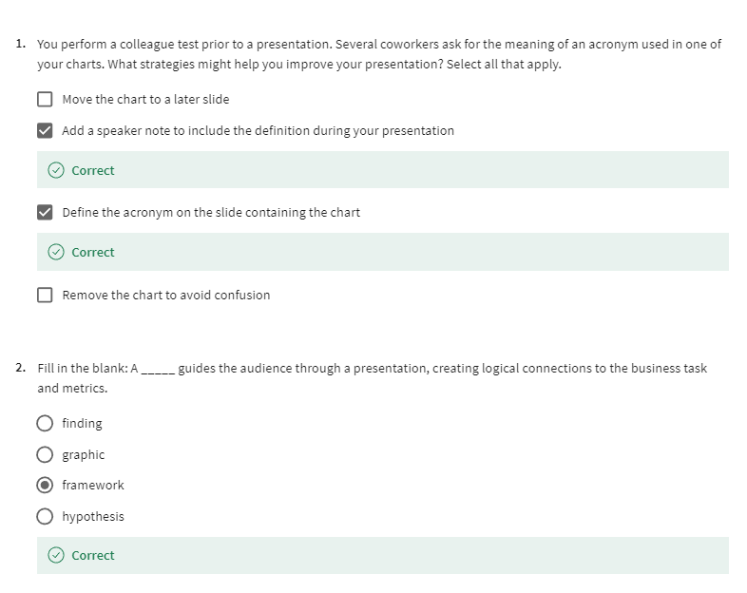

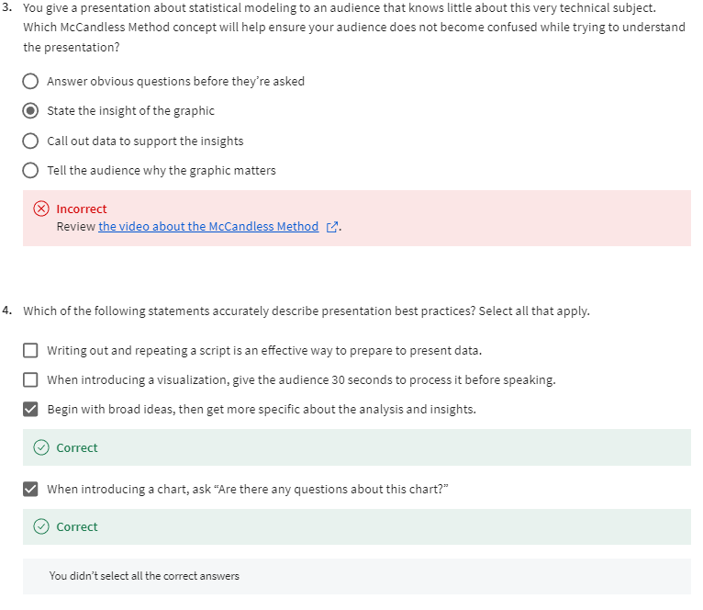

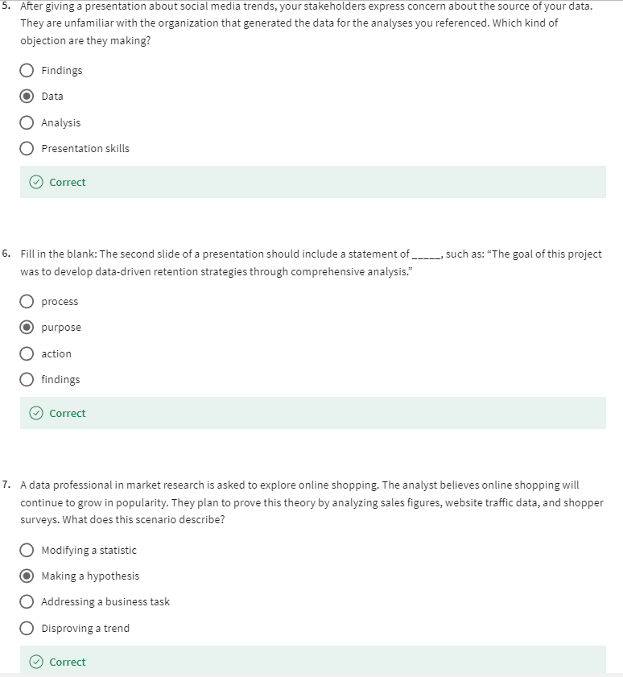

[Glossary terms from module 4](https://www.coursera.org/learn/visualize-data/supplement/Adbqw/glossary-terms-from-module-4)

## **Terms and definitions for Course 6, Module 4**

**Dashboard filter:** A tool for showing only the data that meets a specific criteria while hiding the rest

**Data blending:** A Tableau method that combines data from multiple data sources

**Framework:** The context a presentation needs to create logical connections that tie back to the business task and metrics

**Professional relationship building:** Building relationships by meeting people both in person and online (Refer to Networking)

**Static data**: Data that doesn’t change once it has been recorded

**Statistics:** The study of how to collect, analyze, summarize, and present data

**WITH:** A SQL clause that creates a temporary table that can be queried multiple times

COURSE WRAP-UP

[Course 6 glossary](https://www.coursera.org/learn/visualize-data/supplement/DLisR/course-6-glossary)

[Congratulations! Course wrap-up](https://www.coursera.org/learn/visualize-data/lecture/6azVn/congratulations-course-wrap-up)

Now that you've finished the course challenge, you're officially ready to move on to the next course. Nice! Coming up, Carrie will show you how to use something new: R. R is a programming language that you can use to collect, analyze, and visualize data in new and complex ways. This is different from the skills we've learned so far—just one of the reasons why it's so exciting. You'll also learn more about what programming languages are and how to use R to work with data. Before you move on though, I'd like to thank you for joining me in this course and taking on this learning opportunity. Learning should be a lifelong pursuit, and the work you put into learning opportunities like this class will make you better at anything you choose to do. You have come a long way from the first videos in this program. Take a moment to celebrate your progress and everything you've learned. After that, head on to the next course. Carrie is waiting to help you get started.

[Coming up next...](https://www.coursera.org/learn/visualize-data/supplement/e0mXc/coming-up-next)